### 

### Semester Two Examination, 2020

### Question/Answer booklet

# MATHEMATICS METHODS

**UNIT 1 AND 2**

## Section One:

## Calculator-free

Name: _______________________________________________________

Teacher’s Name:_______________________________________________

## Time allowed for this section

Reading time before commencing work: five minutes

Working time: fifty minutes

## Materials required/recommended for this section

***To be provided by the supervisor***

This Question/Answer booklet

Formula sheet

***To be provided by the candidate***

Standard items: pens (blue/black preferred), pencils (including coloured), sharpener, correction fluid/tape, eraser, ruler, highlighters

Special items: nil

## Important note to candidates

No other items may be taken into the examination room. It is **your** responsibility to ensure that you do not have any unauthorised material. If you have any unauthorised material with you, hand it to the supervisor **before** reading any further.

|  |  |  |  |  |  |
| --- | --- | --- | --- | --- | --- |
| Question | Marks | Max | Question | Marks | Max |
| 1 |  | 7 | 6 |  | 3 |
| 2 |  | 4 | 7 |  | 6 |
| 3 |  | 4 | 8 |  | 4 |
| 4 |  | 6 | 9 |  | 4 |
| 5 |  | 6 |

**Structure of this paper**

|  |  |  |  |  |  |
| --- | --- | --- | --- | --- | --- |
| Section | Number of questions available | Number of questions to be answered | Working time (minutes) | Marks available | Percentage of examination |
| Section One:  Calculator-free | 9 | 9 | 50 | 44 | 34 |
| Section Two:  Calculator-assumed | 14 | 14 | 100 | 85 | 66 |
|  |  |  |  | **Total** | 100 |

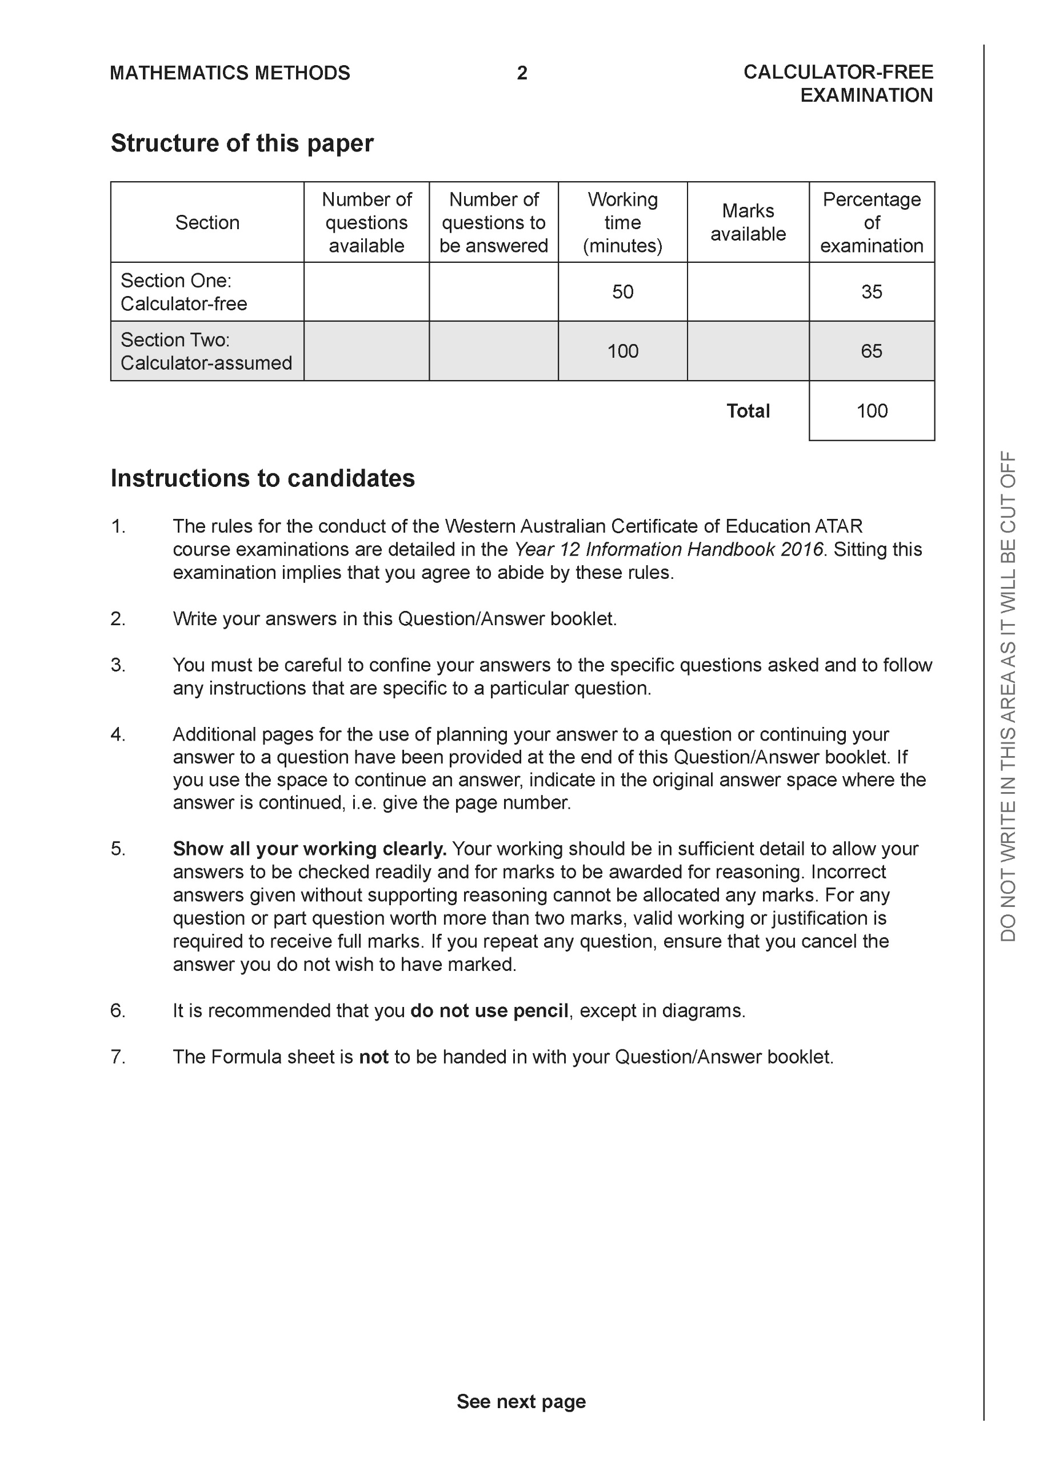

**Section One: Calculator-free (44 Marks)**

This section has **nine (9)** questions. Answer **all** questions. Write your answers in the spaces provided.

Spare pages are included at the end of this booklet. They can be used for planning your responses and/or as additional space if required to continue an answer.

● Planning: If you use the spare pages for planning, indicate this clearly at the top of the page.

● Continuing an answer: If you need to use the space to continue an answer, indicate in the original answer space where the answer is continued, i.e. give the page number. Fill in the number of the question that you are continuing to answer at the top of the page.

Working time: 50 minutes.

Question 1 {2.2.1, 2.2.7} (7 marks)

(a) The second term of a geometric sequence is 15 and the fourth term is 135.

Determine the sum of the first 4 terms of the sequence. (4 marks)

(b) Determine the sum of the first 100 integers

i.e 1+2+3+ ……+99+100. (3 marks)

**Question 2 {2.2.5, 2.1.3} ( 4 marks)**

The fifth term and the ninth term of an arithmetic sequence are 26 and 42 respectively.

Determine the twenty-first term.

**Question 3 {1.1.24} ( 4 marks)**

Determine the natural domain and corresponding range for the following:

|  |  |  |
| --- | --- | --- |
| functions | Domain | Range |
|  |  |  |
|  |  |  |
|  |  |  |
|  |  |  |

**Question 4 {1.2.8, 1.2.10, 1.2.12, 1.2.13} (3, 3 = 6 marks)**

1. Solve the following trigonometric equation



b) Sketch the graph of the following equation





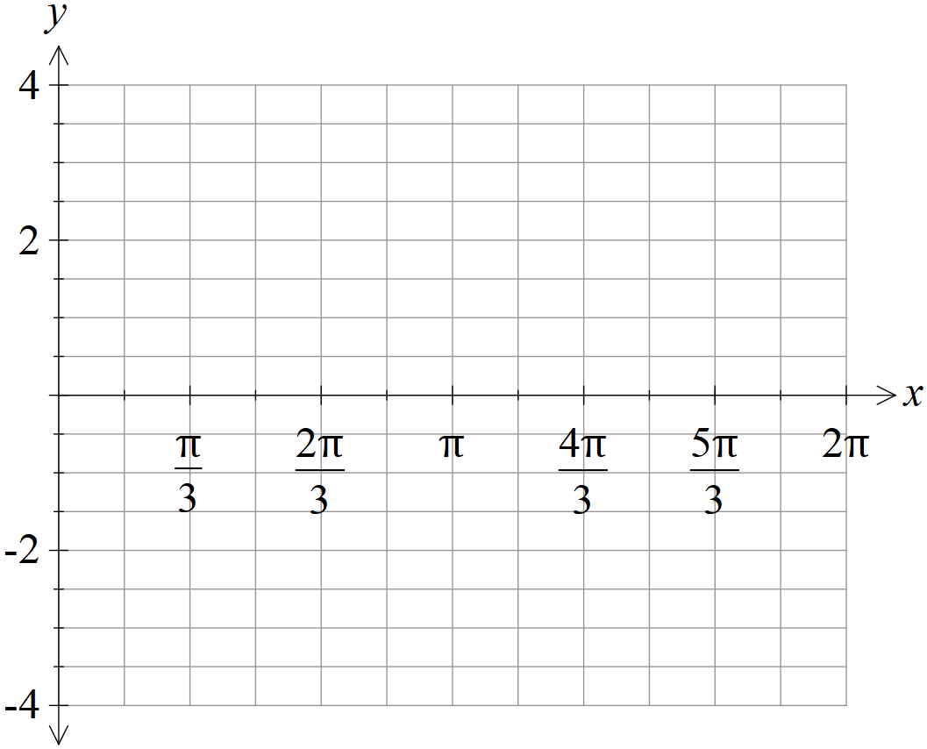

**Question 5 {2.1.2, 2.1.7} (3, 3 = 6 marks)**

On the axes provided, sketch each of the following exponential functions. Remember to label any intercepts or asymptotes.

a) $y=2^{x}+3$



b) $y=0.5×4^{x}-1$



**Question 6 {1.2.16} (3 marks)**

Solve for x:



**Question 7 {1.1.17} (6 marks)**

Show that $x+1$ is a factor of $x^{3}-x^{2}+3x+5$ and then find the quadratic factor.

**Question 8 {1.3.1, 1.3.5} (2, 2 = 4 marks)**

The first four rows of Pascal’s triangle are shown below.

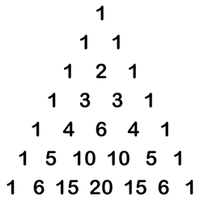

Simplify all answers in this question.

1. Expand the expression ${\left(x-2\right)}^{5}$.
2. Find the third term of the expansion of ${\left(2x-3y\right)}^{4}$

**Question 9 {2.3.15, 2.3.9} (2, 2 = 4 marks)**

1. Find the derivative of the function $f\left(x\right)=\frac{4}{x^{2}}+2x$. Express your answer with positive indices.
2. Find the equation of the curve if the gradient at any point of the curve is given by

$\frac{dy}{dx}=1-2x$ and the curve passes through the point (1,2).

END OF SECTION

Additional working space

Question number:

Additional working space

Question number: